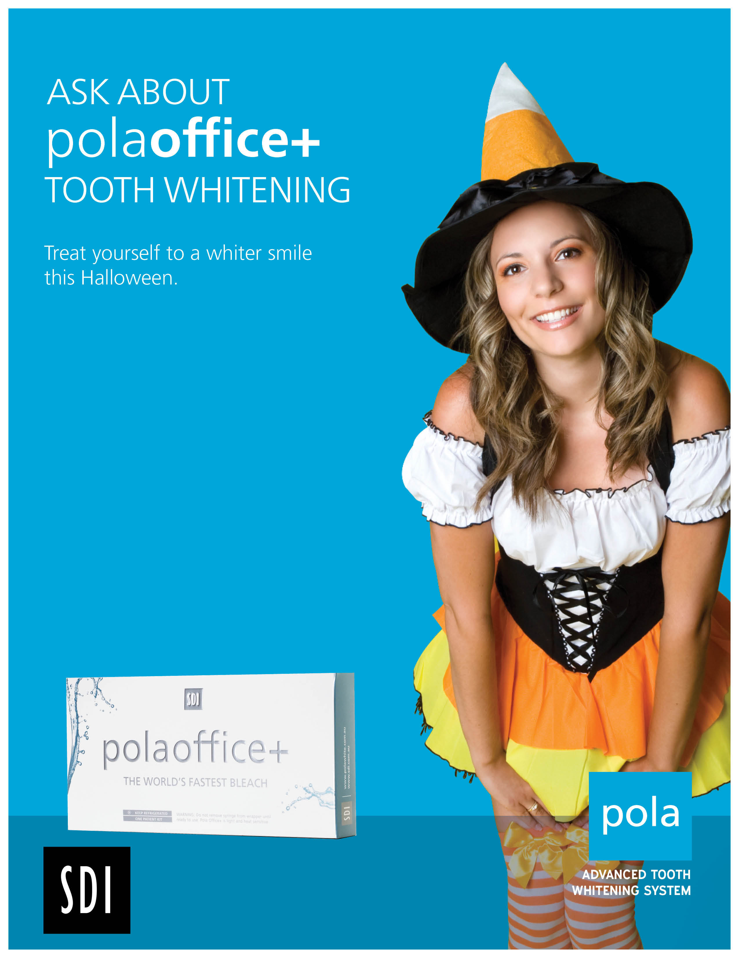
Treatment includes:
• Professional Chairside tooth
whitening using polaoffice+

$200

