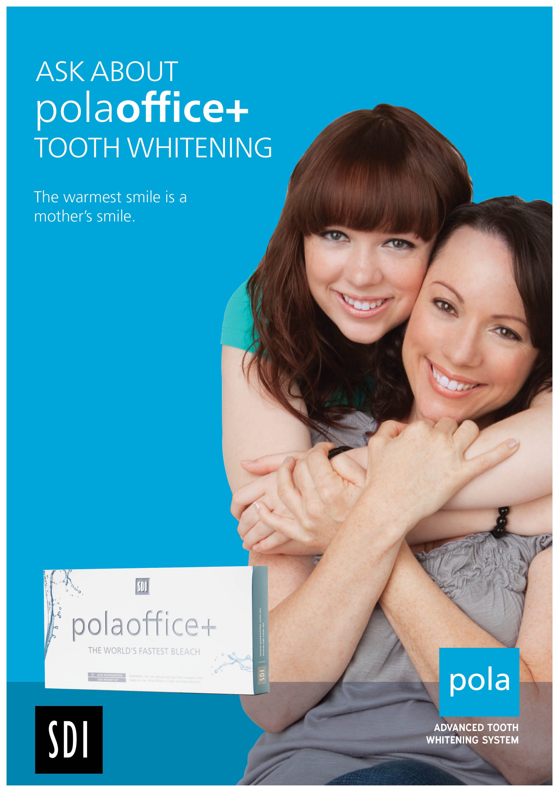
$200

Treatment includes:
• Professional chairside tooth whitening procedure using polaoffice+

