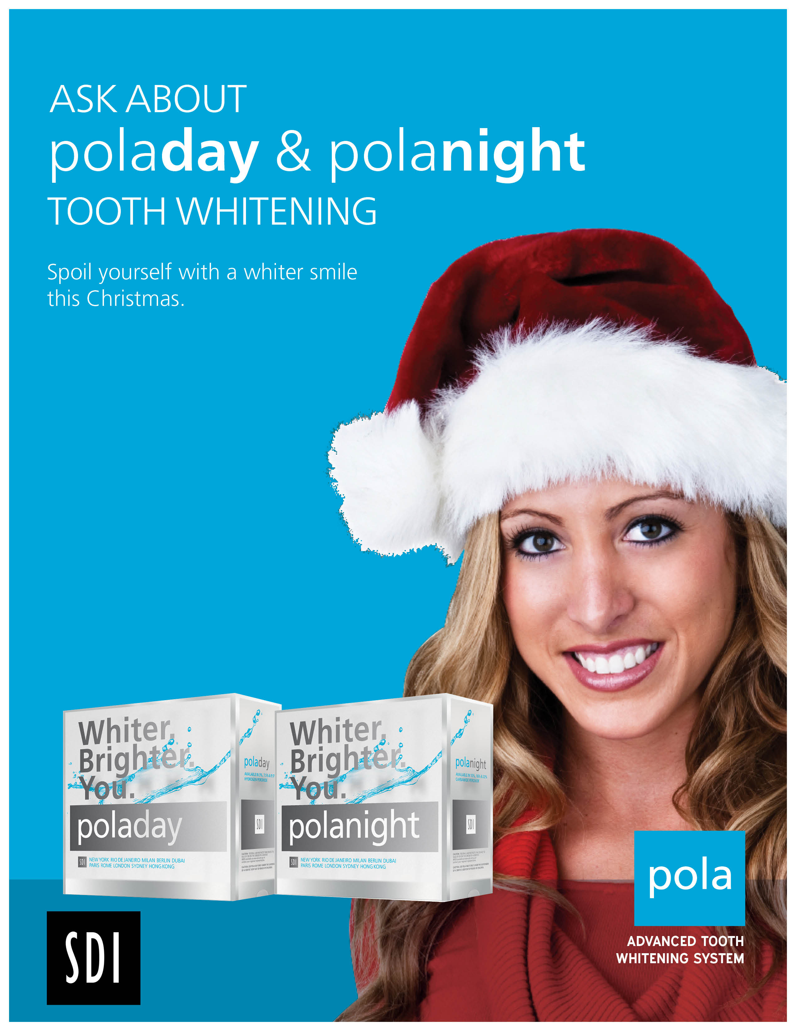
$200

Treatment includes:
• poladay or polanight whitening gel
• Custom-fitted trays

